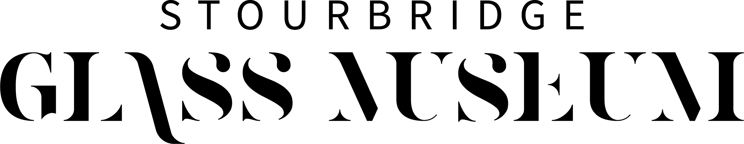

Job Application Form

Please read the guidance for job applicants available on our website before you complete this form.

- Application Details.

Post applied for:
Title: |  |  |  | Surname:
Forename(s):
Address:
Postcode:
Phone (home):
Phone (mobile):
E-Mail:
Preferred contact method:

National Insurance Number (if you have one):
Do you have the Right to Work in the UK?  Please note: original identification documents verifying your right to work in the UK will be requested, checked and a photocopy will be taken. If your application is successful and you commence employment the copy of your identification documents will be retained on file under the regulations governed by the Immigration, Asylum and Nationality Act. |  |  | Yes or No
Where did you hear about this vacancy?

- Education/Qualifications (including overseas). Please start with secondary education.

From  month /year | To  month /year | Secondary School/ |  | Examinations taken | Results | Date
 |  | College/University etc. |  | or to be taken | & grades | gained

3. Training. Please list any course(s) which you have undertaken which are relevant to the job and/or specified on the person specification.

Year | Organising/Awarding Body | Course title | Grade

4. Professional Membership. Please indicate membership of any organisation(s) relevant to this job.

Name of organisation |  |  |  |  | Type of membership |  | Date of membership
5. Present or Most Recent Employment (if any)

From  month /year |  | To  month /year |  | Employer  (name & address) |  | Job Title | Salary
Please outline your main duties including who you were responsible to and your reasons for leaving:

Salary and Benefits:
Notice Period:
Why do you want to leave?
6. Past Employment & Experience (if any) include voluntary or other relevant experience.

From  month /year |  | From  month /year |  | Employer (Name & Address) |  | Job Title | Reason for change and salary on leaving

7. References - Please provide the names and addresses of two referees:

Name and Capacity Known | Occupation / Job Title | Address, Telephone Number and Email
1.

2.

8. Tell us why you are suitable for this role

In order for us to decide whether to call you for interview, it is essential that you provide us with sufficient details of any experience, skills and knowledge which demonstrate how you meet the requirements of this job. You may also continue on one separate sheet if you wish. You should ensure that any additional sheet is attached securely and includes your name.

Please continue on a separate sheet if necessary
9. General Data Protection Regulations 2018

The information detailed in this application form may be used by the museum in the monitoring and progression of its employment policies and practices, and in particular it’s Equal Opportunities in Employment Policy. This monitoring is for statistical purposes only and you will not be identifiable from this process. However, your personal details contained in the application form may be used in the prevention and detection of fraud.
During the course of its employment activities, the museum collects, stores and processes personal information about prospective, current and former staff.
We recognise the need to treat staff personal and sensitive data in a fair and lawful manner. No personal information held by us will be processed unless the requirements for fair and lawful processing can be met.

What types of personal data do we handle?
In order to carry out our activities and obligations as an employer we handle data in relation to:
- Personal demographics (including gender, race, ethnicity, sexual orientation, religion)
- Contact details such as names, addresses, telephone numbers and Emergency contact(s)
- Employment records (including professional membership, references and proof of eligibility to work in the UK and security checks)
- Bank details
- Pension details
- Medical information including physical health or mental condition (occupational health information)
- Information relating to health and safety
- Offences (including alleged offences), criminal proceedings, outcomes and sentences
- Employment Tribunal applications, complaints, accidents, and incident details
We aim to maintain high standards, adopt best practice for our record keeping and regularly check and report on how we are doing. Your information is never collected or sold for direct marketing purposes. Your information is not processed overseas.
What is the purpose of processing data?

- Staff administration and management (including payroll and performance)
- Pensions administration
- Business management and planning
- Accounting and Auditing
- Accounts and records
- Crime prevention and prosecution of offenders
- Education
- Health administration and services
- Information and databank administration
- Sharing and matching of personal information for national fraud initiative

We have a legal basis to process this as part of your contract of employment (either permanent or temporary) or as part of our recruitment processes following data protection and employment legislation.

Sharing your information
There are several reasons why we share information. This can be due to:
- Our obligations to comply with legislation
- Our duty to comply any Court Orders which may be imposed
Any disclosures of personal data are always made on case-by-case basis, using the minimum personal data necessary for the specific purpose and circumstances and with the appropriate security controls in place. Information is only shared with those agencies and bodies who have a "need to know" or where you have consented to the disclosure of your personal data to such persons.
Use of third-party companies
To enable effective staff administration, The museum may share your information with external companies to process your data on our behalf In order to comply with our obligations as an employer.

Consent to The museum recording and processing the information detailed in this application form. I understand that this information may be used by The museum in pursuance of its business purposes and my consent is conditional upon The museum complying with their obligations under the General Data Protection Regulations 2018.

I also confirm that the information contained in this application form is correct.

Signature: Date:

Application forms not fully completed may be refused.

Please return the completed form marked Private and Confidential to:

lboleyn@stourbridgeglassmuseum.org.uk

