**FOR IMMEDIATE RELEASE**  
**21st May 2025**

**Stourbridge Glass Museum Awarded Funding to Restore Iconic Churchill Screen Panel for VE Day 80th Anniversary**

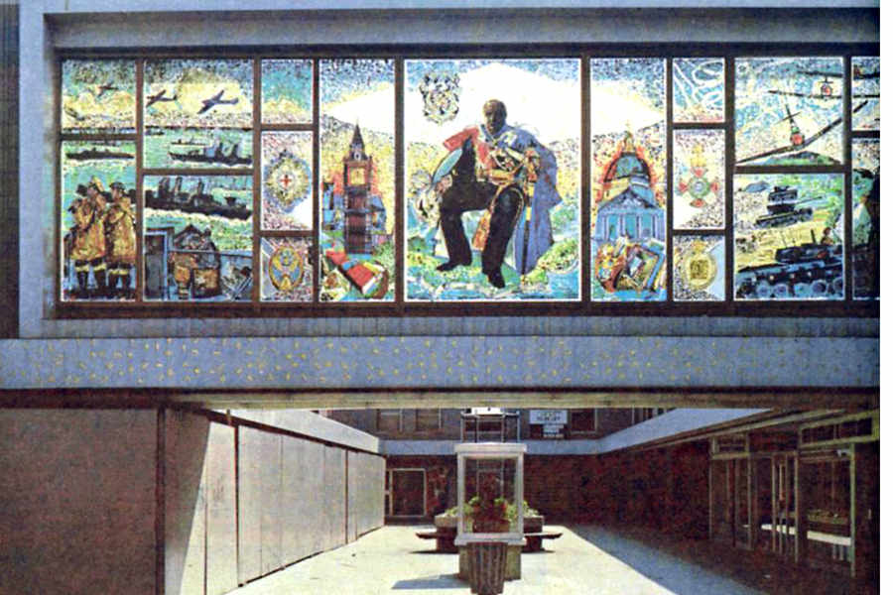

**Stourbridge, UK** — Stourbridge Glass Museum has been awarded a £25,000 *Victory 80 Fund* grant to conserve and reinterpret the historic Battle of the Atlantic Panel from the *Churchill Screen*, a monumental glass artwork created in the 1960s by artist Edward Bainbridge Copnall. The project, supported by the Department for Digital, Culture, Media & Sport (DCMS) and Museum Development Midlands (MDM), will culminate in a permanent display of the panel at the Museum, alongside community events marking the 80th anniversary of Victory in Japan (VJ) Day.

**A Masterpiece with a Turbulent History**

The Churchill Screen, originally spanning 12 metres with 17 panels, depicted Winston Churchill’s life through intricate appliqué glass—a technique bonding coloured glass to clear plate glass. Commissioned for Dudley’s shopping precinct, it was a technical marvel weighing five tonnes. In 1984, vandals shattered its central panels, including the Spitfire-themed section honouring Churchill’s WWII leadership. Fragments were salvaged, but the screen’s fate remained uncertain until Stourbridge Glass Museum assumed ownership in 2024. Only 11 panels of the original 17 are salvageable and the central Churchill panel is seriously damaged.

**Project Highlights**

* **Conservation**: Accredited glass conservator Kirsten Ramsay will stabilise and restore the Battle of the Atlantic Panel for display at Stourbridge Glass Museum, ensuring its preservation for future generations.
* **New Display**: A bespoke, lit exhibition unit will showcase the panel with interpretation exploring Dudley’s wartime glass industry and women’s contributions, on permanent display at the Museum.
* **VJ Day Tea Party**: A free community event on 15 August 2025, featuring reminiscence activities, period dress, and music for the museum and its community groups- join as a member for details.
* **Creative Workshops**: ‘Make Do and Mend’ glassmaking and ‘Skies of Remembrance’ collages workshops will be hosted, inspired by the screen’s designs.
* **Tunnel Tours**: Highlighting the museum’s underground air raid shelters used during WWII, plus new interpretation.

Alexander Goodger, Director of Stourbridge Glass Museum, said:  
*“The Churchill Screen is a cultural treasure- both a testament to the creativity of post-war glass art and a powerful symbol of resilience. This project not only restores a vandalised masterpiece but reconnects the Dudley community with its heritage. The Battle of the Atlantic Panel’s imagery, celebrating Churchill’s leadership, makes it a fitting centrepiece for future VE Day commemorations. 42 years after the panel was vandalised- we will finally be able to showcase a panel fully restored”*

**Event Dates**:

* **VJ Day Tea Party**: 15 August 2025
* **Churchill Screen Launch**: (date TBC- sign up as a member of Stourbridge Glass Museum to get a free invite)

**Notes to Editors**:

* **Press Contact**: Alexander Goodger – [info@stourbridgeglassmuseum.org.uk](mailto:info@stourbridgeglassmuseum.org.uk) | 07866 844314
* **Background**: Read about the screen’s history [here](https://journals.openedition.org/ceroart/5669).
* Here’s a short reel about the screen: <https://www.bbc.co.uk/news/uk-england-birmingham-21783294>

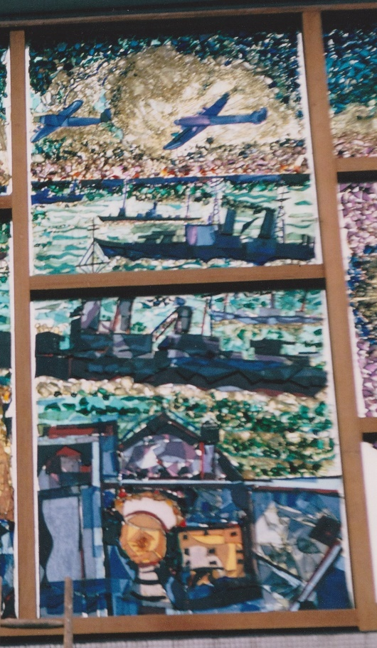

* Panel being conserved and re-displayed

*This project is supported using public funding by the UK Government through Arts Council England.*